HWA4

Task 1:

1. The objective function will be the equation between the number of pizzas to the number of salads s.t. the overall revenue from sales will be maximal. In other words, we want to maximize the sale of foods in the restaurant.
2. The decision variables are how many pizzas to make and how many salads.
3. The constraints are the total amount of amount (grams) for cheese and tomatoes (67,500, 90,000 gram). For every salad and pizza there is a required amount of cheese (90, 360 g) and tomatoes (180, 90 g). Also, the amount cannot be negative.

Task 2:

1. Feasible Solutions:

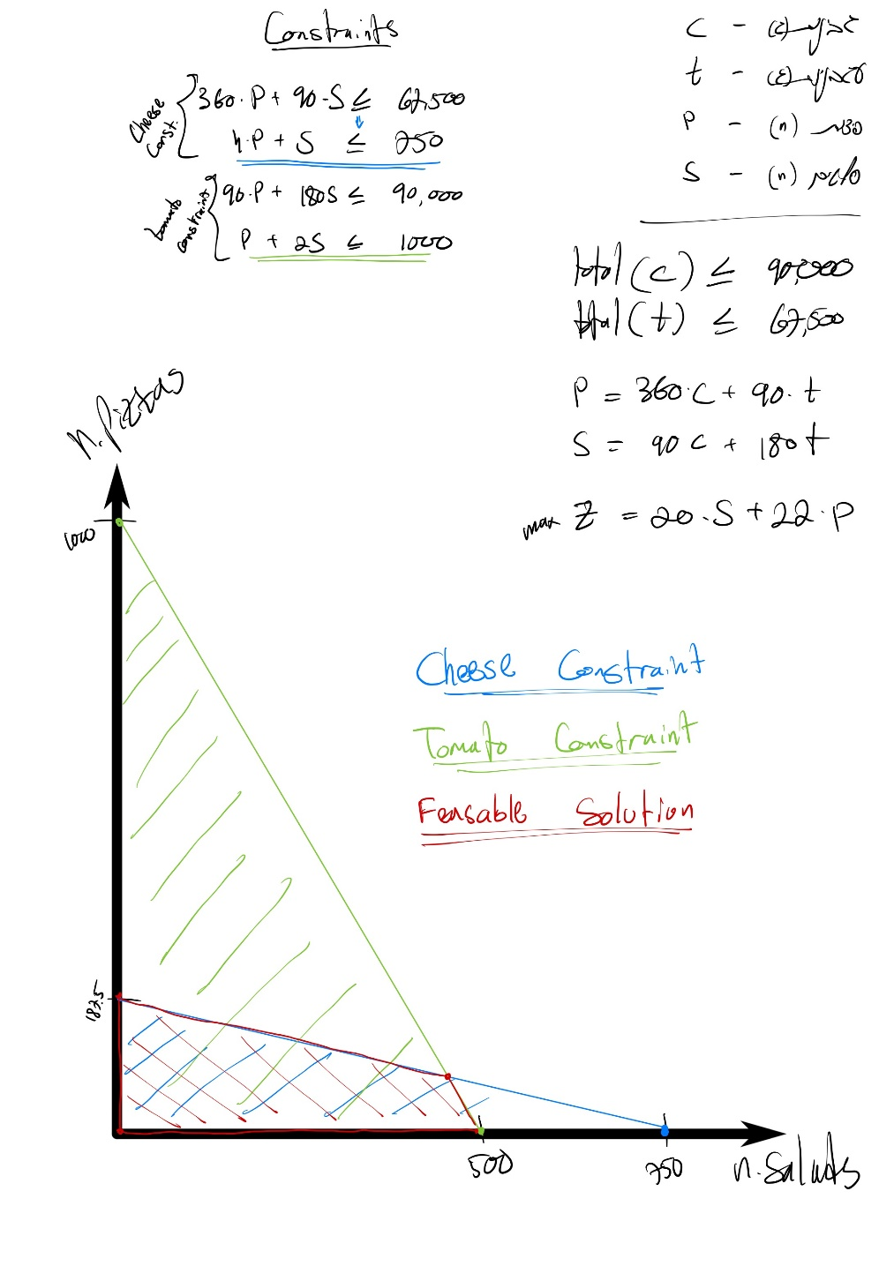

1. Optimum solution:

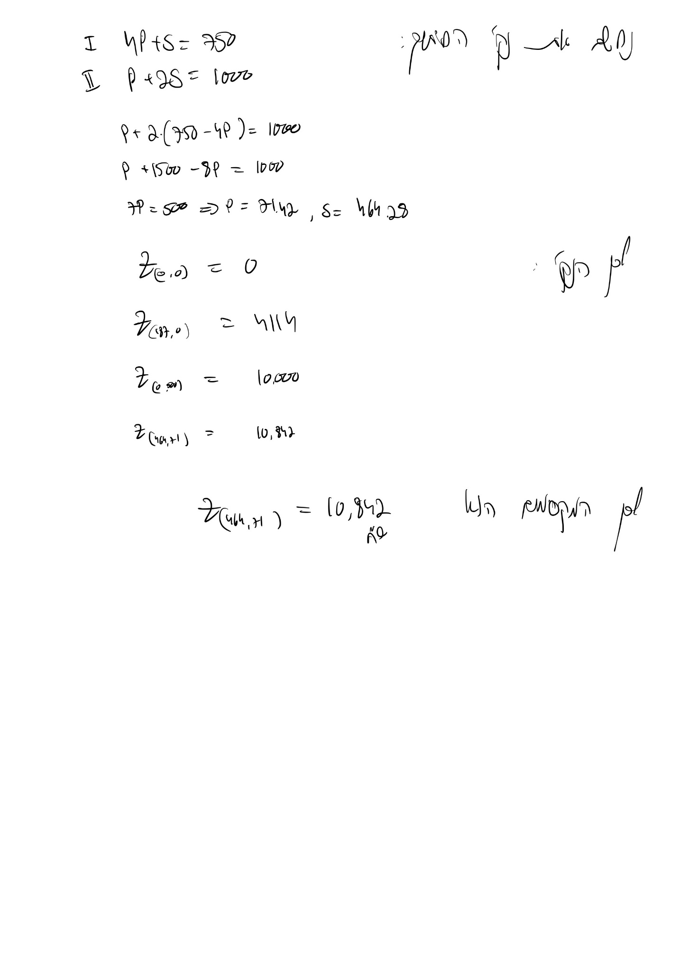We find the best $Z_{max}$ out of all 4 points. We notice that we cannot make pizzas or salad numbers which are not $∈N$. Thus, we round down.

Therefore, the optimum solution would be 71 pizzas, 464 salads.